OPERATING SYSTEMS LAB EXPERIMENTS
1) STUDENT NAME: YADLAPALLI CHAITHANYA
2) REG.NO: 1925260210
3) SUBJECT NAME: OPERATING SYSTEMS
4) SUBJECT CODE: CSA0402 {SLOT:B}
5) SUBMITTED TO: PRISKILLA ANGEL RANI J

Lab Experiment 1
1. Create a new process by invoking the appropriate system call. Get the process identifier of the currently running process and its respective parent using system calls and display the same using a C program.
AIM: Create a new process by invoking the appropriate system call. Get the process identifier of the currently running process and its respective parent using system calls and display the same using a C program.
ALGORITHM:
- Include necessary headers: Include the header files <stdio.h>, <unistd.h>, <sys/types.h> and <sys/wait.h> for using system calls.
- Declare variables: Declare a variable of type pid_t to hold the process ID returned by fork().
- Create a new process: Use the fork() system call to create a new process. Check the return value of fork() to determine whether the code is running in the parent or the child process.
- Get the current process ID: Use the getpid() system call to retrieve the process ID of the current process.
- Get the parent process ID: Use the getppid() system call to retrieve the parent process ID.
- Display process IDs in child and parent processes: If fork() returns 0, display the process ID and parent process ID of the child. If it returns a positive value, wait for the child to finish, then display the process ID, the parent process ID and the child process ID of the parent.
PROGRAM:
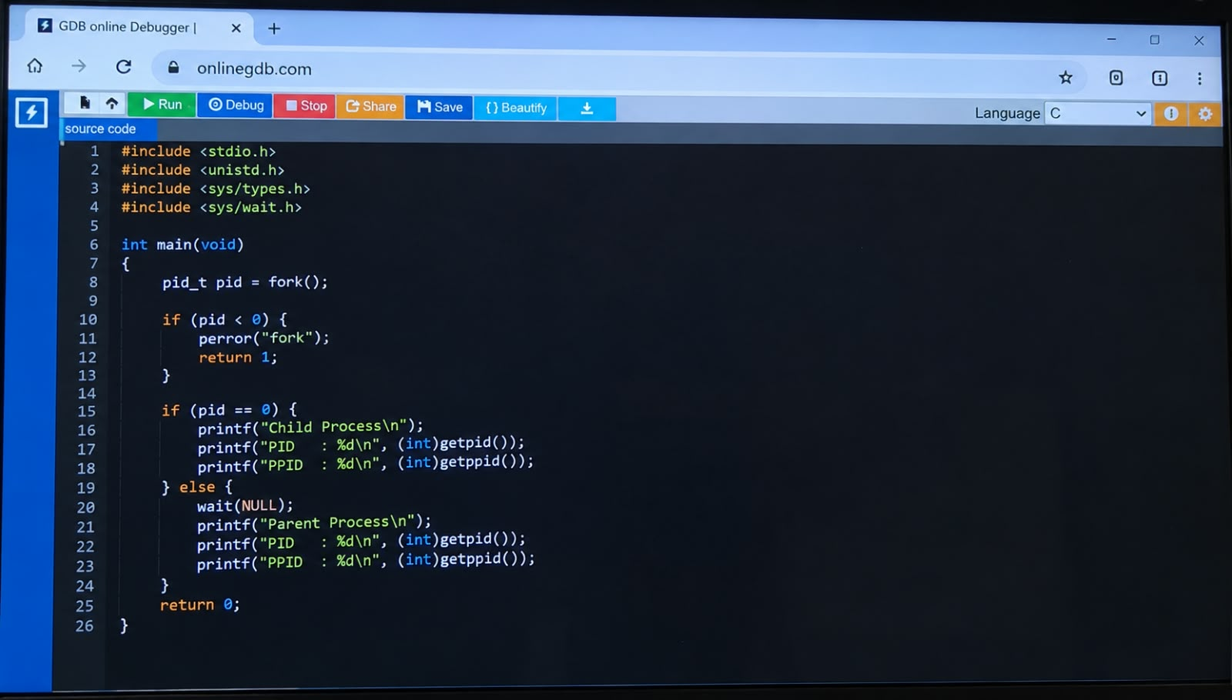

OUTPUT

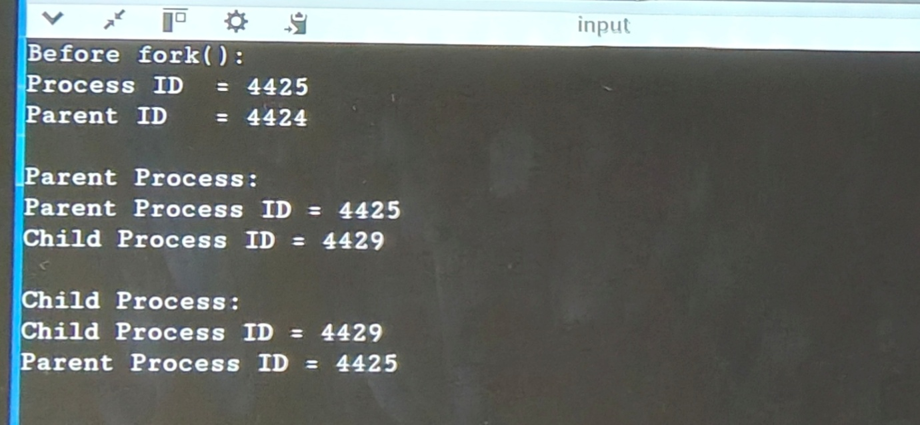

RESULT
The new process was successfully created using the fork() system call. The process ID (PID) and parent process ID (PPID) of the child and parent processes were successfully obtained using getpid() and getppid() and displayed

